Mr. Nelson – Sociology 101
Race Excerpts

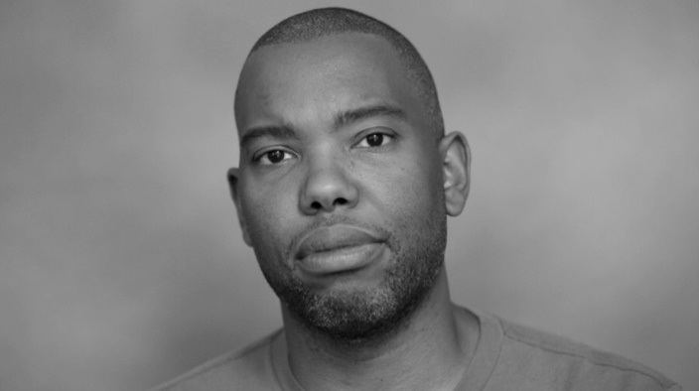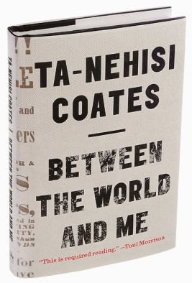
Ta-Nehisi Coates, Between the World and Me (2015)

Americans believe in the reality of “race” as a defined, indubitable feature of the natural world. Racism – the need to ascribe bone-deep features to people and then humiliate, reduce, and destroy them – inevitably follows from this inalterable condition. In this way, racism is rendered as the innocent daughter of Mother Nature, and one is left to deplore the Middle Passage or the Trail of Tears the way one deplores an earthquake, a tornado, or any other phenomenon that can be cast as beyond the handiwork of men.
But race is the child of racism, not the father. And the process of naming “the people” has never been a matter of genealogy or physiognomy so much as one of hierarchy. Difference in hue and hair is old. But the belief in the preeminence of hue and hair, the notion that these factors can correctly organize a society and that they signify deeper attributes, which are indelible – this is the new idea at the heart of these new people who have been brought up hopelessly, tragically, deceitfully, to believe that they are white.
These new people are, like us, a modern invention. But unlike us, their new name has no real meaning divorced from the machinery of criminal power. The new people were something else before they were white – Catholic, Corsican, Welsh, Mennonite, Jewish…it must be said that the process of washing the disparate tribes white, was not achieved through wine tastings and ice cream socials, but rather through the pillaging of life, liberty, labor, and land; through the flaying of backs; the chaining of limbs; the strangling of dissidents; the destruction of families; the rape of mothers; the sale of children; and various other acts meant, first and foremost, to deny you and me the right to secure and govern our own bodies. (p. 6-8)
- Define the concepts of: Race, Ethnicity, and Nationality (differentiate them), as outlined in your notes.
- Regarding the concept of race, describe the meaning of the underlined passages, as you understand them.
*Note – Ta-Nehisi Coates’ work, Between the World and Me, is written in the narrative style of a letter to his 15 year old son.
I write to you in your fifteenth year. I am writing you because this was the year you saw Eric Garner choked to death for selling cigarettes; because you know Renisha McBride was shot for seeking help, that John Crawford was shot down for browsing in a department store. And you have seen Tamir Rice, a twelve-year-old child whom they were oath-bound to protect. And you have seen men in the same uniform pummel Marlene Pinnock, someone’s grandmother, on the side of a road. And you know now, if you did not before, that the police departments of your country have been endowed with the authority to destroy your body. It does not matter if the destruction is the result of an unfortunate overreaction. It does not matter if it originates in a misunderstanding. It does not matter if the destruction springs from a foolish policy…the destroyers will rarely be held accountable. Mostly they will receive pensions. And destruction is merely the superlative form of a dominion whose prerogatives include friskings, detainings, beatings, and humiliations. All of this is common for black people. No one is held responsible. There is nothing uniquely evil in these destroyers or even in this moment. The destroyers are merely men enforcing the whims of our country, correctly interpreting its heritage and legacy. It is hard to face this. But all of phrasing – race relations, racial chasm, racial justice, racial profiling, white privilege, even white supremacy – serves to obscure that racism is a visceral experience, that it dislodges brains, blocks airways, rips muscle, extracts organs, cracks bones, breaks teeth. You must never look away from this. You must always remember that the sociology, the history, the economics, the graphs, the charts…all land, with great violence, upon the body.” (p 9-10).
- Describe Coates’ arguments here regarding black people’s bodies as it relates to institution authority in America (e.g., police and other structural authorities)
*This section is on Coates’ upbringing in Baltimore
“It was always right in front of me. The fear was there in the extravagant boys of my neighborhood, in their large rings and medallions, their big puffy coats and full-length fur-collared leathers, which was their armor against their world…I think back on those boys now and all I see is fear, and I all I see is them girding themselves against the ghosts of the bad old days when the Mississippi mob gathered ‘round their grandfathers so that the branches of the black body might be torched, then cut away. The fear lived on in their practiced bop, their slouching denim, their big T-shirts, the calculated angle of their baseball caps, a catalog of behaviors and garments enlisted to inspire the belief that these boys were in firm possession of everything they desired.
- What rationale does Coates ascribe to the way black youth in his childhood dressed and acted as they did?
To be black in the Baltimore of my youth was to be naked before the elements of the world, before all the guns, fists, knives, crack, rape, and disease. The nakedness is not an error, nor pathology. The nakedness is the correct and intended results of policy, the predictable upshot of people forced for centuries to live under fear…But a society that protects some people through a safety net of schools, government-backed home loans, and ancestral wealth but can only protect you with the club of criminal justice has either failed at enforcing its good intentions or has succeeded at something much darker. However you call it, the result was our infirmity before the criminal forces of the world. It does not matter if the agent of those forces is white or black – what matters is our condition, what matters is the system that makes your body breakable.” (p. 17-18)
- Here he makes a macro-level argument regarding policy – identify and describe that argument

Manning Marable, The Great Wells of Democracy (2002)
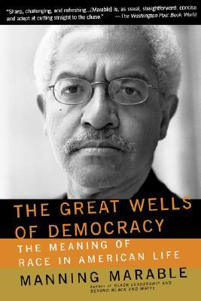
…how did African people become known as ‘black’, or in Spanish, “Negro”? Europeans launching the slave trade across the Atlantic 400 years ago created the terminology as a way of categorizing the people of an entire continent with tremendous variations in language, religion, ethnicity, kinship patterns, and cultural traditions. Blackness, or the state of being black, was completely artificial; no people in Africa prior to the transatlantic slave trade and European colonialism called themselves ‘black.’ Blackness only exists as a social construct in relation to something else. That “some else” became known as ‘whiteness.’ Blackness as a category relegates other identities – ethnicity, sexual orientation, gender, class affiliation, religious traditions, kinship affiliations – to a secondary or even nonexistent status…without a racialized “Other”, ‘whites’ cease to exist.

On Race and Citizenship

As ethnic studies scholars such as Gary Okihiro and Ronald Takaki have observed, the 1790 Naturalization Act defined citizenship only for immigrants who were “free white persons.” U.S. courts constantly redefined the rules for determining who was “white” and who was not. For example, Armenians were originally classified as “Asians” and thus were nonwhite, but they legally became “whites’ by a 1909 court decision. Syrians were ‘white’ in court decisions in 1909 and 1910; they became ‘non-white’ in 1913, and became “white” again in 1915. Asian Indians were legally white in 1910, but they were classified as nonwhite after 1923…This concept helps us to understand why the vast majority of Asians born in Asia who emigrated to the United States were not legally allowed to become citizens until 1952. It explains why Native Americans, the only truly indigenous group to the continent, were excluded from citizenship until 1924. It also illustrates why the majority of African Americans, who had been formally extended the rights of citizenship in 1865, did not actually vote in a presidential election until 1968.

The Myth of Police Reform

By Ta-Nehsis Coates, The Atlantic Magazine
The real problem is the belief that all our social problems can be solved with force.
There is a tendency, when examining police shootings, to focus on tactics at the expense of strategy. One interrogates the actions of the officer in the moment trying to discern their mind-state. We ask ourselves, "Were they justified in shooting?" But, in this time of heightened concern around the policing, a more essential question might be, "Were we justified in sending them?" At some point, Americans decided that the best answer to every social ill lay in the power of the criminal-justice system. Vexing social problems—homelessness, drug use, the inability to support one's children, mental illness—are presently solved by sending in men and women who specialize in inspiring fear and ensuring compliance. Fear and compliance have their place, but it can't be every place.
When Walter Scott fled from the North Charleston police, he was not merely fleeing Michael Thomas Slager, he was attempting to flee incarceration. He was doing this because we have decided that the criminal-justice system is the best tool for dealing with men who can't, or won't, support their children at a level that we deem satisfactory. Peel back the layers of most of the recent police shootings that have captured attention and you will find a broad societal problem that we have looked at, thrown our hands up, and said to the criminal-justice system, "You deal with this."
- What argument (thesis) is Coates making about the role of the police in our society? How do you think he feels about this?
Last week I was in Madison, Wisconsin, where I was informed of the killing of Tony Robinson by a police officer. Robinson was high on mushrooms. The police were summoned after he chased a car. The police killed him. A month earlier, I'd been thinking a lot about Anthony Hill, who was mentally ill. One day last month, Hill stripped off his clothes and started jumping off of his balcony. The police were called. They killed him. I can't see the image of Tamir Rice aimlessly kicking snow outside the Cleveland projects and think of how little we invest in occupying the minds of children. A bored Tamir Rice decided to occupy his time with a airsoft gun. He was killed.
There is of course another way. Was Walter Scott's malfunctioning third-brake light really worth a police encounter? Should the state repeatedly incarcerate him for not paying child support? Do we really want people trained to fight crime dealing with someone who's ceased taking medication? Does the presence of a gun really improve the chance of peacefully resolving a drug episode? In this sense, the police—and the idea of police reform—are a symptom of something larger. The idea that all social problems can, and should, be resolved by sheer power is not limited to the police. In Atlanta, a problem that began with the poor state of public schools has now ending by feeding more people into the maw of the carceral state.

There are many problems with expecting people trained in crime-fighting to be social workers. In the black community, there is a problem of legitimacy. In his 1953 book The Quest For Community, conservative Robert Nisbet distinguishes between "power" and "authority." Authority, claims Nisbet, is a matter of relationships, allegiances, and association and is "based ultimately upon the consent of those under it." Power, on the other hand, is "external" and "based upon force." Power exists where allegiances have decayed or never existed at all. "Power arises," writes Nesbit, "only when authority breaks down."
African Americans, for most of our history, have lived under the power of the criminal-justice system, not its authority. The dominant feature in the relationship between African Americans and their country is plunder, and plunder has made police authority an impossibility, and police power a necessity. The skepticism of Officer Darren Wilson's account in the shooting of Michael Brown, for instance, emerges out of lack of police authority—which is to say it comes from a belief that the police are as likely to lie as any other citizen. When African American parents give their children "The Talk," they do not urge them to make no sudden movements in the presence of police out of a profound respect for the democratic ideal, but out of the knowledge that police can, and will, kill them.
But for most Americans, the police—and the criminal-justice system—are figures of authority. The badge does not merely represent rule via lethal force, but rule through consent and legitimacy rooted in nobility. This is why whenever a liberal politician offers even the mildest criticism of the police, they must add that "the majority of officers are good, noble people." Taken at face value this is not much of a defense—like a restaurant claiming that on most nights, there really are no rats in the dining room. But interpreted less literally the line is not meant to defend police officers, but to communicate the message that the speaker is not questioning police authority, which is to say the authority of our justice system, which is to say—in a democracy—the authority of the people themselves.
How does Coates distinguish between ‘authority’ and ‘power’, and how does he relate these concepts to the relationship between police and black communities, historically?
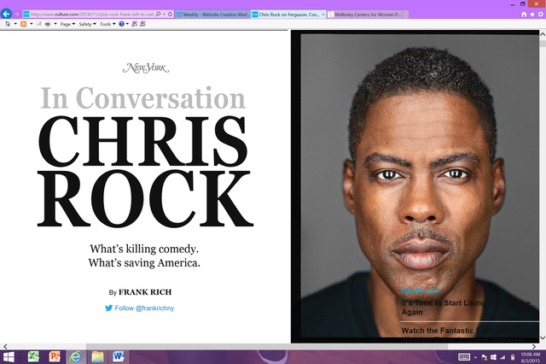
*The following are excerpts from a larger interview given by comedian Chris Rock:
Your own kids are all girls, right?
All girls. I mean, I almost cry every day. I drop my kids off and watch them in the school with all these mostly white kids, and I got to tell you, I drill them every day: Did anything happen today? Did anybody say anything? They look at me like I am crazy.
And you think this change is generational? That maybe it has nothing to do with Obama?
It’s partly generational, but it’s also my kids grew up not only with a black president but with a black secretary of State, a black joint chief of staff, a black attorney general. My children are going to be the first black children in the history of America to actually have the benefit of the doubt of just being moral, intelligent people.
Well, that would be much more revealing.
Yes, that would be an event. Here’s the thing. When we talk about race relations in America or racial progress, it’s all nonsense. There are no race relations. White people were crazy. Now they’re not as crazy. To say that black people have made progress would be to say they deserve what happened to them before.
Right. It’s ridiculous.
So, to say Obama is progress is saying that he’s the first black person that is qualified to be president. That’s not black progress. That’s white progress. There’s been black people qualified to be president for hundreds of years. If you saw Tina Turner and Ike having a lovely breakfast over there, would you say their relationship’s improved? Some people would. But a smart person would go, “Oh, he stopped punching her in the face.” It’s not up to her. Ike and Tina Turner’s relationship has nothing to do with Tina Turner. Nothing. It just doesn’t. The question is, you know, my kids are smart, educated, beautiful, polite children. There have been smart, educated, beautiful, polite black children for hundreds of years. The advantage that my children have is that my children are encountering the nicest white people that America has ever produced. Let’s hope America keeps producing nicer white people.
- Describe Rock’s arguments regarding the progress of white America

