Sephora Saint-Armand
Topic- Race, Racism, Social Construction of Race/Identity, Gender
Colorism in the Black Community on a Gender-Based Focus
Research Questions
Principal Inquiry: How does colorism interact with gender and influence black identity?
What is colorism?
What does colorism mean to the black community?
What gender roles do black people adhere to?
How does the black community perpetuate colorism amongst themselves?
How do “outer groups” perceive colorism and associated characteristics?
Hypothesis
I predicted the results obtained from this experiment would show colorism favored those of a lighter complexion- both male and female. Conversely, colorism proved disadvantageous to those of darker skin tone with regard to media exposure, job opportunity, and idealized beauty standards. Social perception and interactions within the community would perpetuate this idea, reinforced by through social media and dating trends.
Methodology: Interview and Survey(s)
Interviews
I conducted 2 interviews. Interview A included black males/females of varying skin tone.
-3 black males, 1 black female
Interview B included two non-black interviewees
-1 South Asian male, 1 White female
Interview A and B questions (italicized indicates questions also asked in Interview B)
1. What stereotypes are associated with lighter and darker skin complexions? Can you categorize them based on gender?
2. Do you think any of them hold any truth? And if so, how?
3. How do these stereotypes hold any value in defining the standard of beauty for males and females?
4. Have they ever influenced your attitudes and behavior?
5. How do you think these stereotypes are enforced?
6. What standards must black males live up to? Females?
7. Data shows that people think media exposure favors lighter skinned females and males. Why do you think that is? (solely Interview B)
Interview A
1. “I think lighter skin complexion is synonymous with higher intelligence, kindness and beauty in the black psyche. Black heterosexual males are seen as more emotionally in tune, which is ridiculed within the black community and speaks to the persisting narrative of emotional restraint and being stoic at all odds in the black community. Heterosexual dark skin females are seen as more masculine and brutish (i.e. Michelle Obama or Serena Williams).”(Sidney Saint-Hilaire)
“Dark skinned males are deemed the epitome of masculinity and sometimes unintelligent. They remain the idea black male within the community (i.e. Denzel Washington).Conversely, lightly skinned females are the ideal and deemed submissive to their significant others, articulate, and more likely to possess European traits like lighter eyes or straighter hair. They are also associated with affluence and high and mighty attitude. Darker females are deemed undesirable, loud, and prone to using synthetic beauty enhancers (i.e. weaves, extensions) or having appealing sexual assets. Depending on culture and time, perception of light skinned males change. Previously, they were seen as more European and very intelligent/articulate (biracial men usually lead black movements) and attractive due to hair. However, change in preference for hair texture and length associated more masculinity in darker men, hence why “light skin” is used pejoratively amongst black males.” (Allen Pierre-Louis)
“Dark skin males are deemed savages and crude behavior. Light skin males are associated with sensitivity. Conversely, dark skin females are associated with being ghetto and loud, which light skin girls are infamous for the elusiveness, and difficulty in relationships.” (Harris Pavlou)
“ Light skin girls are prettier, dubbed “red bones” for the European features (i.e. straighter/looser hair texture). Weaves are used as a way to perpetuate the stereotype. Darker girls are considered meaner, those who wear their hair naturally are unapproachable. They are “ratchet” when they do something that defies cultural norms within the black community (i.e. fashion, hair styles), and have attitude problems.”(Zaire Couloute)
2. “Not all black people adhere to these roles, but of course there are cases in which people do fit these prescribed roles.” (Harris Pavlou)
“The stereotype that darker skinned women are abrasive/ have attitude problems is the direct result of the antagonistic sentiment harbored by the black community towards darker women, coupled with contempt, particularly from men. This contributes to their general defensive behavior and closed off manner- thus leading to a self-fulfilling prophecy in which the stereotype perpetuates itself. Darker skinned males are more likely to pride themselves as heartbreakers and savages- used as an availability bias to justify their actions, adhering to the pre-determined role.” (Zaire Couloute)
3. “These stereotypes defined what black beauty meant in the western world since its creation. Lighter skin black people have not only had greater visibility and access to equality (i.e. Rosa Parks rather than Claudette Colvin) and have perpetuated the beauty standards themselves because of the lack of introspection within the community as a whole concerning this matter.” (Sidney Saint-Hilaire)
“I believe that these stereotypes have been so deeply engrained in the black psyche that they perpetuate as true. Respectively institutionalized, lighter boys and girls benefit as more approachable, cuter and more docile. Their darker counterparts are viewed as meaner, callous, and unapproachable.”(Zaire Couloute)
4. “…I never really focused on my race…but I do see contempt in the black community for intelligent/timid black males, especially from black females who rend o expect stereotypical hyper masculinity from myself and others. This has always made me a bit apprehensive and kept me away from certain interactions. Black males on this “personality spectrum” tend to gravitate toward other racial community and marry into those due to lack of acceptance within their own.” (Allen Pierre-Louis)
5. “Stereotypes are preached to us since birth. Sexualizing a light skinned girl at a young age, telling her she will be a pretty red bone when she gets older and attract many boys, while telling darker girls their skin is akin to charcoal, their hair is too hard to comb through, and they already have an attitude problem. Light skinned young boys are lauded for their lighter complexion by family members, claiming he will be nice to girls and have a soft heart. These boys, preached this stereotype go on to live up to this standard. Darker boys, fed the construction of “dark skin savagery” are in turn, more apt to be emotionally detached and cold-hearted.” (Zaire Couloute)
6. “ The emergence of the growing “black female” culture- an intersection of black feminism and pride calls them to return to their “roots”, giving up synthetic beauty enhancers and other things associated with Europeanism. The majority is those of darker pigment who suffered the brunt of colorism. Some tie the positive natural hair movement with pan Africanism, which excludes the more conservative black women, typically of lighter complexion.” (Allen Pierre-Louis)
Analysis
All the interviewees agreed that being darker served as a disadvantage, particularly romantically. Both male(s) and female interviewees alike believed that the idealized perception favored lighter skinned women, though their seemed to be some disparities in the opinion of lighter skinned people. Interviewee Allen thought lighter skinned men were outcasted by the black community, while Interviewee Zaire thought lighter skinned men were more likely candidates for relationships, and their emotional sensitivity served as an attractive feature. As for darker people, Sidney’s observation that beauty standards have been a disservice to dark people contrasts with Zaire’s in-depth analysis comparing men and women- claiming that darker men were not affected by the beauty standard.
Interview B
1. I usually see lighter skinned males depicted as “players” as well as self-centered/vain. The consensus for those of darker skin is that they are unattractive- particularly females. On social media, there is a debate about masculinity between the two skin tones, where light skin males are more feminine, while darker males are thuggish and savages.” (Theodora Catrina)
“There’s definitely a stereotype that darker skinned people are more “rough” than their lighter counterparts. People with darker complexions are unrefined- whether it be typical depictions of gang bangers in the inner city or unable to gain a proper education (lack of assets). Blacks with lighter complexions are perceived in the near opposite fashion, deemed more educated and capable. They are associated with traditional wealth and granted more opportunities for idealized success. Generally, lighter implies better.” (Mohammad Samroz)
2. “Society most certainly favor lighter complexion as the replica of beauty. Within my own community [South Asian] people perceive lighter skin as cleaner and thereby more wealthy, privileged and attractive. Though times are changing and there is a growing appreciation for darker colored people in fashion and movie industry, the bias that darker skin equates brutishness/ugliness remains potent. A typical model commercial (i.e. Calvin Klein) shows a bunch of white people with a few light skinned black people that could easily pass for white. The standard is not the same for both darker men and women. There are few exemplary models of darker skinned beauty (i.e. Lupita Nyongo, Viola Davis) in Hollywood, while there are ample examples of darker men (i.e. Idris Elba, Denzel Washington). (Mohammad Samroz)
7. “Seemingly in all cultures people with lighter complexion are viewed as superior in some way and more attractive. You could spend a lot of time trying to discern the roots of the arbitrary preference dependent on culture. Social media, and it’s pervasive nature perpetuate these stereotypes and continues to influence people’s mindset and perception.”(Theodora Catrina)
Analysis
The interviewees mainly focused on their observances from the “outgroup”, gaining perspective from social media and representation. They both agree that lighter skinned people have more media visibility and are regarded as “black beauty”. Mohammad’s parallel to South Asian community molded his perception that darker skin disadvantage is not exclusive to the black community, but perpetuates in other colored communities as well. The interviewees perception of light skinned men and women aligns with the intervieewes of Interview A, though Interviewees of B elaborated on the perception on social media and stereotypes internalized and affirmed by society. Theodora’s keen observation of the debate of masculinity and the femininity vs. “thuggishness” serve to provide an outside perspective of someone who is not affected by colorism (unlike Mohammad or other interviewees)
Survey
For the survey, a total of 55 responses* were received, respondents categorized by gender, race and self-identified skin tone. By race: 24 Afro-Caribbean/African-American; 16 South Asian; 3 East Asian; 9 Hispanic/Latino; 9 White (Caucasian). By gender: 17 male; 37 female. By skin tone: 37 identified as dark/light skinned; 19 neither.
*Not all questions received the same amount of responses, influencing accuracy
The purpose of these preliminary questions was to categorize the research sample, and observe any trends in responses based on gender and race. Additionally, my ability to discern the data and account for bias depended on the respondent’s identity, which hints at the perception and experience the respondent may have with the topic. People of color, particularly African-American/Afro-Caribbean are more likely to have prior knowledge to colorism and notice its impact in current society from personal experience, while Whites due to lack of experience most likely rely on availability heuristics to gauge understanding of the topic.
Questions
1. Please select your identified race (select more than one if necessary): African-American/Afro-Caribbean, South Asian, East Asian, Hispanic/Latino, White
- 43.64% identified as Afro-Caribbean/African-American
-29.09% identified as South Asian
-5.45% identified as East Asian
-16.36% identified as Hispanic/Latino
-16.36% identified as White
This question aimed to categorize the participants and recognize patterns in responses, providing insight into the possible perception of a group of people. It is noted the predominant amount of responses were from black people. The sample was not equally representative of all races as it skewed to the perception of one group. This variable influences data accuracy and reliability of the results.
2. Gender: 1) Female 2) Male 3) Trans 4) Other
-31.48% identified as male
-68.52% identified as female
The intent of this question was to gauge the gender of respondents and another way to categorize responses. Patterns from responses delineates by gender. This will help in analysis of later questions, particularly dealing with general attractiveness, and stereotypes associated with males and females of lighter and dark complexions.
3. Do you identify as a dark or light skinned?: Yes, No, Neither
-65.45% identified as dark/light skinned
-35.54% did not
The question was meant to discern the participants’ self-identification of skin tone. This would come into play later in regard to questions about media exposure based on complexion, attractiveness and stereotypes as well. This furthers the previous racial question, splitting respondents into groups based on skin tone, which may influence the opinion. Those of lighter complexion responses’ may differ from that of darker complexion due to different experiences with colorism (positive and negative,respectively) while those who identified as neither served as “neutral party”, largely representing the outer group with no experience or personal bias.
4. Why?: 1)I’ve been told my complexion is dark or light by others 2) I am comparatively darker/lighter than others in my race 3) Social media influenced my distinction 4) I’ve always known 5) I didn’t previously choose yes or no
-27.8% selected I’ve been told my complexion by others
-38.89% selected I am comparatively darker/lighter than others
-24.07% selected I didn’t choose yes or no in the previous question
-9.56% selected I’ve always known
-0% chose social media
The question serves to show where the respondents’ self-identification derives from. As expected many chose comparatively darker and lighter skin. It should be noted that this never specified what standard they held themselves to-intraracial or interracial. If their reasoning was intraracial, there are internal identification measures that help delineate skin color. Within the black community in particular, the brown paper bag test was previously used as a way to identify “privileged” blacks- those lighter than the paper bag were typically of the black upper class, exposed to the refined arts and socialize with other elites. This standard was since then as a way to identify darker and lighter black people. Other colored races follow the same trend, associating lighter skin with white skin, a lasting impact of white supremacy and previous classism(prejudice towards one social class), associating skin with social class as well (lighter was more affluent, darker was poorer).
5. Has skin tone ever played a role in your attraction to someone? 1) Never, I don’t think that matters 2) I am more likely to find darker people more attractive 3) I am more likely to find lighter people more attractive
-52.73% of respondents chose I don’t think that matters
-12.73% of respondents chose I am more likely to find darker people more attractive
-34.55% of respondents chose I am more likely to find lighter people more attractive
Surprisingly, the vast majority chose that their preference doesn’t align with color, which goes against previous evidence that suggests it does. Data collected from dating websites, such as OkCupid show that across the board, nearly every race found black women and men least desirable, while the vast majority of both men and women held white women/men in a positive regard.
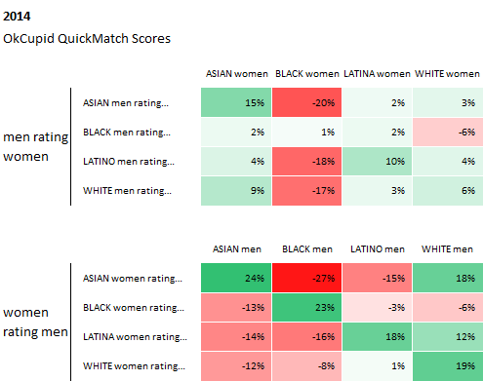
6. On average, which do you find more attractive? Choose according to sexual preference. 1) Lighter skinned females 2) Darker Skinned females 3) Darker skinned males 4) Lighter skinned females
-28.3% of respondents found lighter skinned females more attractive
-5.66% of respondents found darker skinned females more attractive
-22.64% of respondents found lighter skinned males more attractive
-43.4% found lighter skinned males more attractive
-2 respondents skipped this question
As expected, though many previously said they had no preference, ,lighter skinned females and males were found more attractive than their darker counterparts. A study released by researchers Darrick Hamilton, Arthur Goldsmith, and William Darity (Shedding Light on Marriage: The influence of skin shade on marriage) reveal that among black women under 30, the marriage rate increases as skin color lightens. 55% of lighter skinned black women have been married as opposed to a mere 23% of darker skinned black women. This corroborates with the evidence, as darker skinned females received the least (5.6%) in contrast to 28% of lighter skinned females (note there were fewer male than female respondents).

7. According to your last preference, when you find the other skin tone attractive, do you find this an exception or something unordinary? 1) Yes 2) No
-12.73% of respondents said yes they are traditionally unattractive to me
-82.87% of respondents said no
The majority of respondents deemed that finding the other skin tone attractive isn’t an exception. This suggests that though of them gravitated toward one skin tone they do not consider their counterpart generally unattractive.
8. When you see a lighter skinned female/male, does the thought of mixed racial background ever cross your mind? 1) Yes, they have facial features and hair texture that suggests they could be of a multi-racial background 2) No
-78.18% of respondents said yes, they have facial features and hair texture that suggest mult-racial background
-21.82% of respondents said no
The question served to identify the general perception of lighter skinned people being associated with Europeanized features. Many lighter skinned black people, particularly women, with smoother hair texture are deemed “mixed”. Furthermore, this mixed heritage is considered an attractive feature, a direct linkage to slavery. Marquita Golden, author of “Don’t Play in the Sun: One Women’s Journey through the Color Complex” writes “…The belief in superiority of light skin and European hair-like features, is among African-Americans, a legacy of slavery.” Therefore, many presume light skin people are a mixture of another race closer to that of European descent. Typically, those of East African ancestry, are misperceived as European due to looser hair pattern, lighter skin and European facial features.
9. When you see a darker skinned female/male, does the thought of a mixed racial background ever cross your mind? 1)Yes, they have facial features and hair texture that suggests a multi-racial background 2)No
-26.42% of respondents deemed that darker skinned people were not considered of mixed race
-73.68% of respondents said no
-2 respondents skipped
Conversely, many respondents did not assume darker skinned people are of mixed lineage. This question intended to contrast the assumption of racial background with darker people and show a correlation between skin color and racial heritage.
10. Who do you generally see casted in movies/shows? Choose one male and female. 1) lighter skinned males 2) Darker skinned males 3)Darker skinned females 4) Lighter skinned females
-80.00% of respondents said Lighter Skinned males
-87.27% of respondents said lighter skinned females
-24.64% of respondents said darker skinned males
-3.64% of respondents said darker skinned females
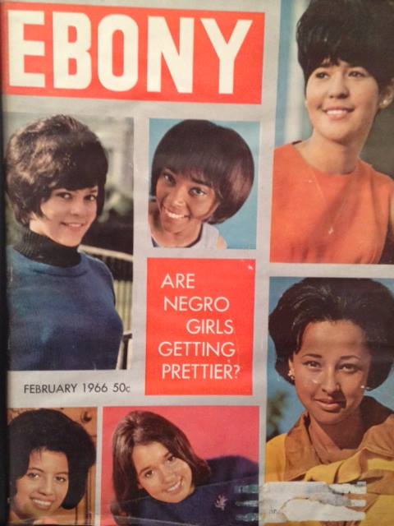
The question serves to indicate public opinion about visibility based on skin tone. It is important to note the majority of respondents are black, and presumably hyper-aware of this subject. More respondents from varying racial backgrounds would provide accurate data. Since the early days of black representation in media, lighter skin people were viewed as more appealing/ acceptable for the American public and became the archetype of black beauty (by both white and black TV producers, fashion, and magazines) . Thus, those that were darker were not associated with traditional beauty because they didn’t adhere to Western beauty standards. This systemic advantage for lighter skinned people still exists. Today, female actresses are typically lighter skinned, and with the exception of a few (Gabrielle Union, Lupita N’yongo, Viola Davis) darker skinned actresses play supporting/minor roles. This is not the same for men-- recently darker skinned men (though fetishized for their “dark/chocolate/exotic) gained more visibility in media and (Djimon Honsou, Denzel Washington, Taye Diggs) are regarded as generally attractive, though still overshadowed by lighter skinned men. Their ruggedness and masculinity deem them acceptable, befitting of their gender role. Darker men in film and TV are casted to play antagonist, criminal or villainous roles (i.e. Blair Underwood in Tyler Perry’s “Madea’s Family Reunion”, Steve Harris vs.Shgamar Moor in “Dairy of A Mad Black Woman”). This issue shows the intersection of gender and colorism. Though both dark, women suffer more in media representation because they don’t follow gender role of beauty (the Western standard) and femininity, while men are not as affected, due to the gender role of masculinity (dark men are characterized as tough, see later) and less emphasis on physical appearance for men. This trend carries over to the music industry as well. Darker female singers/rappers are nearly nonexistent (excluding Nina Simone, Missy Elliot, Lil Mama pre-surgery) while light skinned females are commonplace (Nicki Minaj, Beyonce, Rihanna, Ciara etc.). Note that darker females listed are mainly rappers, while lighter females are mainly R&B.R&B generally touts romance, relationships, dependency and emotional vulnerability, best-suited for the feminine and delicate gender role women are expected to adhere to.However, many darker women find minimal opportunity, deemed unattractive by the general public. For males, it does not follow the same pattern. Hip-Hop has created opportunity for darker men to gain popularity in the music industry (2 Chainz, Kendrick Lamar,OG Maco, Akon, Usher etc.). Light skinned men, however, are more prominent in R&B style and “soft rap” ( J.Cole, Drake). This is also an intersectional factor, as hip-hop bolsters independence, entrepreneurial success, and lavish lifestyle- all factors attributed to men (traditional breadwinners). Therefore, Hip-Hop fits the gender schema for men, though the delicacy and dependency that are associated with gender roles for women contradict their success in this genre-light or dark.
11. Which traits would you associate with lighter skinned males? Choose as many as necessary.
1)Educated; well-spoken 2)Effeminate (womanly) 3) Uneducated, ungroomed 4) Self-centered and vain 5) womanizer 6) tough, a man’s man
-50% of respondents chose educated, well spoken
-32.61% chose effeminate
-2.17% chose uneducated, ungroomed
-60.87% chose self-centered and vain
-76.09% chose womanizer
-10.87% chose a man’s man
- 9 respondents skipped
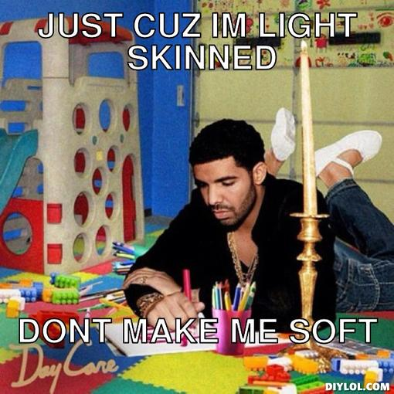
The date shows that the majority viewed lighter skinned men as a womanizer, educated/well spoken, and self-centered. Surprisingly a lesser amount chose effeminate, and as expected masculinity and uneducated were the least popular characteristics. This data (educated/well-spoken) confirms previous analysis of the paper bag test and skin tone oriented classism, though not as potent as the past. Additionally, the self-centered perception can be traced back to lighter skin being regarded as the idealized beauty standard and delicate. This delicacy contradicts the masculinity that men are expected to exude, emphasized in the black community. Therefore, lighter skinned men are at a disadvantage, viewed as effeminate for their delicacy, emotionally expressivity (i.e. Drake, Prince) and “high-maintenance” care of their skin to preserve their “caramel complexion” (looked at with contempt by men, who should be indifferent to their looks).
12. Which traits would you associate with darker skinned males?
1)Educated; well-spoken 2)Effeminate (womanly) 3) Uneducated, ungroomed 4) Self-centered and vain 5) womanizer 6) tough, a man’s man
-41.30% of respondents chose educated/well-spoken
-2.17% of respondents chose effeminate
-23.19% of respondents chose uneducated,ungroomed
-15.22% chose self-centered
-27.83% chose a womanizer
-91.30% chose tough, a man’s man
As expected, an overwhelming amount of respondents deemed darker men “tough”. Unexpectedly, there is a marginal difference between lighter skinned and darker skinned men characterized as well-spoken/educated. Though the majority of the statistics fall in a medium range, there is a stark contract in the perception of light and dark skinned men being perceived effeminate. This affirms the previous statement about black men’s masculinity being tied to “toughness” and “rugged” appearance. Additionally, the perception of darker men being “tough” is bolstered by the media- the rap industry is dominated by darker men who deem themselves as cold, pragmatic and emotionally detached. Similarly, media representation of darker men as thugs (i.e. Chief Keep, Young Thug,ASAP Ferg/Rocky) amplifies the “savage” demeanor attributed to darker men, embracing this perception and gaining positive feedback. However, darker skin does have disadvantages, particularly in the justice system. A Stanford University study (conducted by Professor Eberhardt) found that darker skinned males with Africanized features (broad nose, big lips) are twice as likely to the death sentence as fairer skinned men. Previously, skin tone influenced job opportunities (during the 20th century, lighter skin was required for domestic, service or specialized work) offered to African-Americans, which influenced job availability for darker men.
13.Which traits would you associate with darker skinned females?
1) uncouth, ill-mannered “ratchet” 2)uneducated, ungroomed 3) unpleasant attitude 4)romantically deceitful, standoffish
-61.76% of respondents chose uncouth, “ratchet”
-14.71% chose uneducated
-50% chose unpleasant attitude
-38.24% chose standoffish
-21 skipped
The data shows that many respondents found darker females unpleasant and “ratchet”. Ratchet, closely associated with ghetto (a word that has evolved to describe something poorly made, unrefined manner, often used to describe black people) is exclusive to women. Darker women in media are portrayed as crude (i.e. Sweet Brown’s viral video, “Ain’t Nobody Got Time for that”) and considered ungroomed in contrast to their delicate lighter counterparts. Just like dark men, darker women are perceived as masculine (i.e. Serena Williams,Michelle Obama), which clashes with the gender role of delicacy, dependency and timidity. Dating back to slavery, darker women (traditionally field slaves) were known for enduring harsh work, unlike lighter skinned slaves who worked in the house. Today, dark women struggle with relationships (lower marital rates) and their non-European features are viewed as unattractive, not suiting the idealized beauty standard. A study conducted by Villanova Study found that women with lighter skin were sentenced to 12% less time behind bars than darker women. Additionally, the study revealed that lighter skinned women reduced actual time served by approximately 11%.
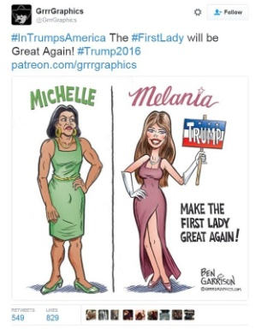
14. Which traits would you associate with lighter skinned females?
1) uncouth, ill-mannered “ratchet” 2)uneducated, ungroomed 3) unpleasant attitude 4)romantically deceitful, standoffish
-5.14% said uncouth
-12.82% said uneducated,ungroomed
-71.79% said unpleasant attitude
-61.54% said standoffish
-16 skipped
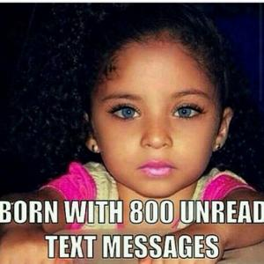
As expected, many found lighter skinned females to be standoffish and unpleasant. This characterization is common within the black community. Men, find lighter skinned women elusive and very desirable, as their lighter skin tone is a “heritable asset” (coming with privileges for their children that darker skinned women could not offer). Often, light-skinned women are fetishized, adored for their fair complexion and lauded as a “mixed mami” and loose curl texture. As aftormentioned, fairer skin is associated with beauty and delicacy, which aligns with their gender role. From the four perspectives, light-skinned women seem to be the biggest beneficiaries (despite the need to prove blackness and disdain from their dark counterparts with words like high yellow or red bone).
Conclusion
As explained, the issue of colorism in an intersectional one. Diretly stemming from slavery, it is perpetuated both internally and externally. Lighter skin is considered a privilege--from jobs, relationships, media representation and social perception. A product of white supremacy, lighter skin gradually became asset, a privilege to have. Although lighter skinned people are clearly beneficiaries of this system, they face much contempt within the black community, denigrated for not being genuine or “black enough”. Their darker counterparts suffer the brunt of colorism, though the double standard shows this is an issue is also gendered. While darker men have gained respect and positive regard, women are degraded for the darker skin and “masculinity”. My initial hypothesis was correct in that it largely proves disadvantegous to darker skinned people and advantageous to lighter skinned people, the lack of a gendered outlook disproved this theory. Lighter black people, particularly men struggle with identity and solidarity with the black community, while darker men have recently gained positive regard from both the black and outer community for their hyper masculinity. Though all black people are still subject to racism, analysis and research shows colorism is just as important.

Sources
1. http://superselected.com/skin-tones-are-gendered-and-colorism-is-a-gender-issue/
2.http://www.theroot.com/articles/politics/2011/07/color_bias_do_lightskinned_blacks_get_shorter_sentences.html
3. http://www.npr.org/templates/story/story.php?storyId=5457607
4. http://racerelations.about.com/od/understandingrac1/a/What-Is-Colorism.htm
5. http://colorismhealing.org/colorism-in-relationships/

